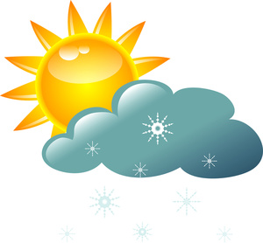
My Daily Weather Log
Date | Today is: | Drawing or Visual of Today’s Weather | Temp | Humidity | Barometer | Wind Speed
- Cloudy
- Rainey
- Sunshine
- Foggy
- Snowy
- Overcast
- Windy
- Stormy
- Other:
- Cloudy
- Rainey
- Sunshine
- Foggy
- Snowy
- Overcast
- Windy
- Stormy
- Other:
- Cloudy
- Rainey
- Sunshine
- Foggy
- Snowy
- Overcast
- Windy
- Stormy
- Other:
- Cloudy
- Rainey
- Sunshine
- Foggy
- Snowy
- Overcast
- Windy
- Stormy
- Other:
http://www.ksl.com/index.php?nid=233&city_input=84070

