School Weather Predictions

- Look at the 3 pictures taken at the school in April. Tell what types of clouds you see in each picture and estimate the amount of cloud cover on each of the days.

 | Day 1 | Day 2 | Day 3
Type of Cloud
Estimate on percentage of cloud coverage

- Look again at the type of clouds in each picture. Do you think that any of these clouds produced rain or snow later in the day? Justify your reasoning.

 | Day 1 | Day 2 | Day 3
Rains?
Yes or No
Justification

- The pictures portray the weather for 3 weeks at your school. Could you predict the cloud types and cloud cover for the next 3 weeks based on the last photo taken? Explain why.

Table 1: Air Temperature Information at 12:00 pm.
Week | Date | Temperature at Noon | Precipitation
Week 1 | April 1 | 0°C | 2.5”
 | April 6 | 10°C | 0”
Week 2 | April 8 | -4°C | 3.0”
 | April 12 | 15°C | 0”
 | April 13 | 21°C | 0”
Week 3 | April 15 | 0°C | 0”
 | April 17 | 11°C | 1.5”
 | April 19 | 10°C | 1.2”
Week 4 | April 21 | 15°C | 2.0”
 | April 27 | 12°C | 0”
Week 5 | April 28 | 5°C | 0”
 | April 29 | 22°C | 0”
 | May 1 | 15°C | 2.5”
 | May 3 | 20°C | 3.0”
Week 6 | May 6 | 11°C | 0”
 | May 8 | 13°C | 0”
 | May 10 | 24°C | 0”

- Use the data from Table 1 and make 2 line graphs. One graph showing the daily weather temperature, and the other showing the amount of precipitation each day.

- Look at the bar graph you just completed. Do you see a general trend in your data?

- Predict the air temperature at school on June 4th, three weeks from when the last photo was taken. Tell how you made this prediction.
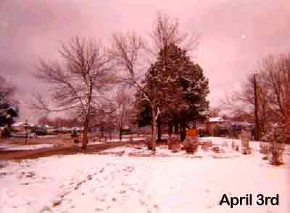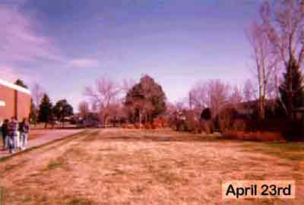
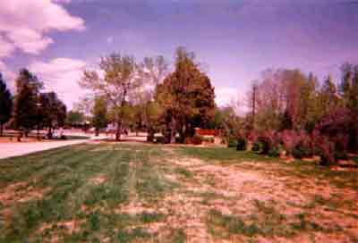
May 10

